**Name: Omkar Pralhad Gharat.**

**Enrollment No.: 2101950**

**Cloud Computing Practical-4**

**\*\*\*\*\*\*\*\*\*\*\*\*\*\*\*\*\*\*\*\*\*\*\*\*\*\*\*\*\*\*\*\*\*\*\*\*\*\*\*\*\*\*\*\*\*\*\*\*\*\*\*\*\***

**Create an S3 Bucket, Upload a file to S3 Bucket, Retrieve a File from S3 Bucket, Delete a File From S3 Bucket using AWS.**

**\*\*\*\*\*\*\*\*\*\*\*\*\*\*\*\*\*\*\*\*\*\*\*\*\*\*\*\*\*\*\*\*\*\*\*\*\*\*\*\*\*\*\*\*\*\*\*\*\*\*\*\*\***

**Step-1:** **Login into AWS student Login**

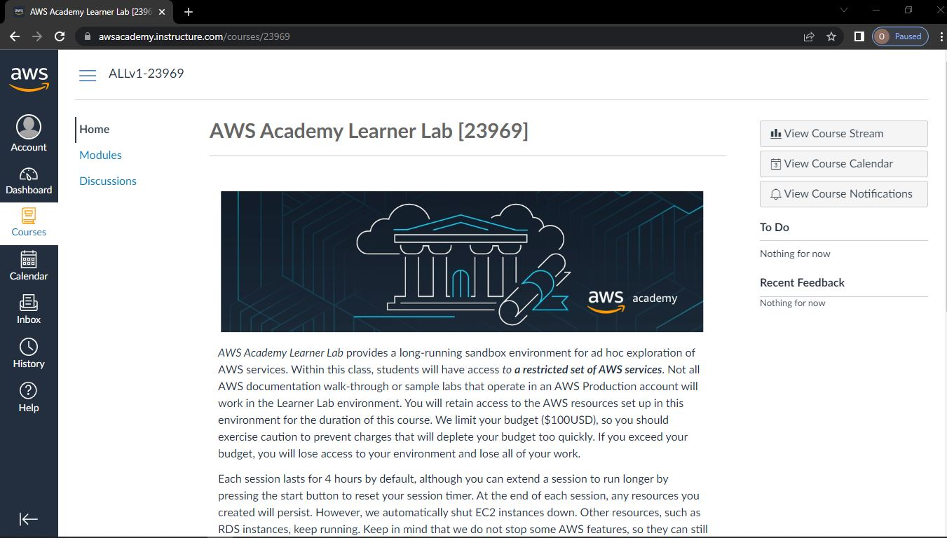

**Step-2: Click on module -> Select Learner Lab -> Click on AWS with indicated green light**

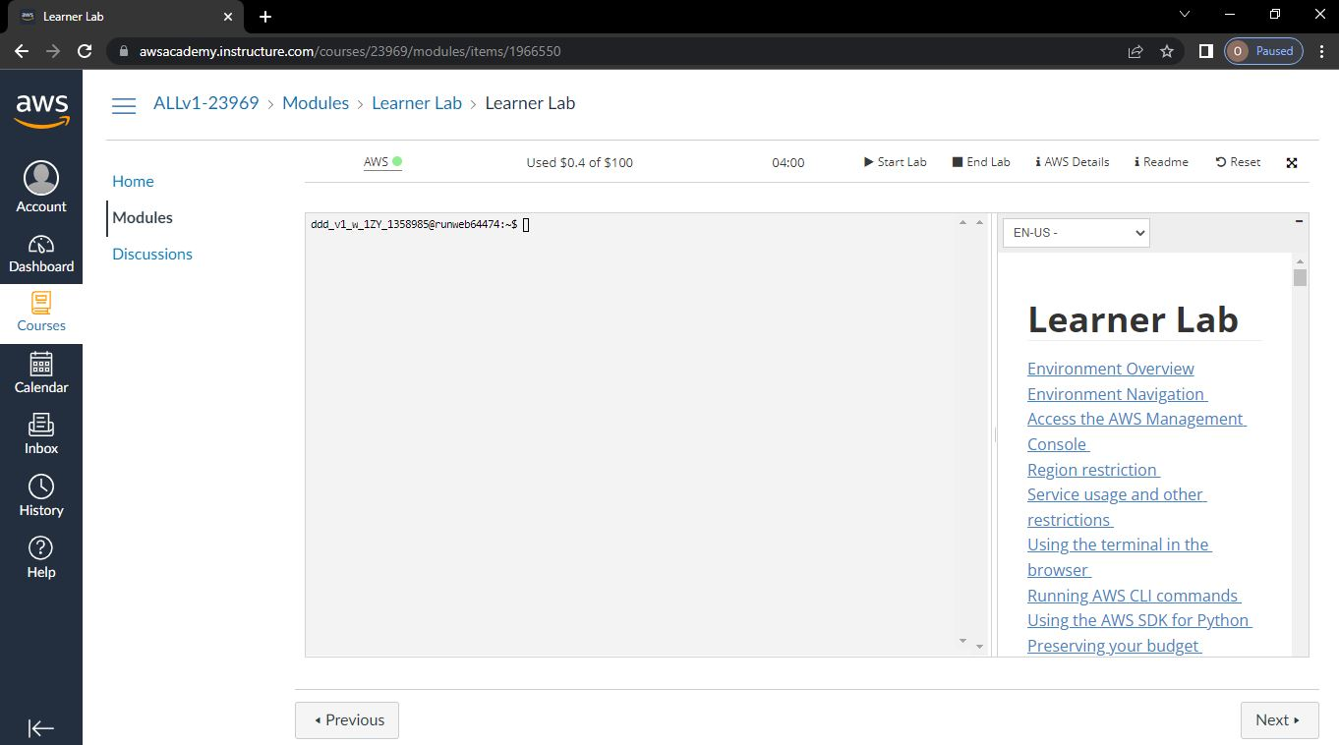

**Step-3: Go to Services -> Below that select Storage-> S3**

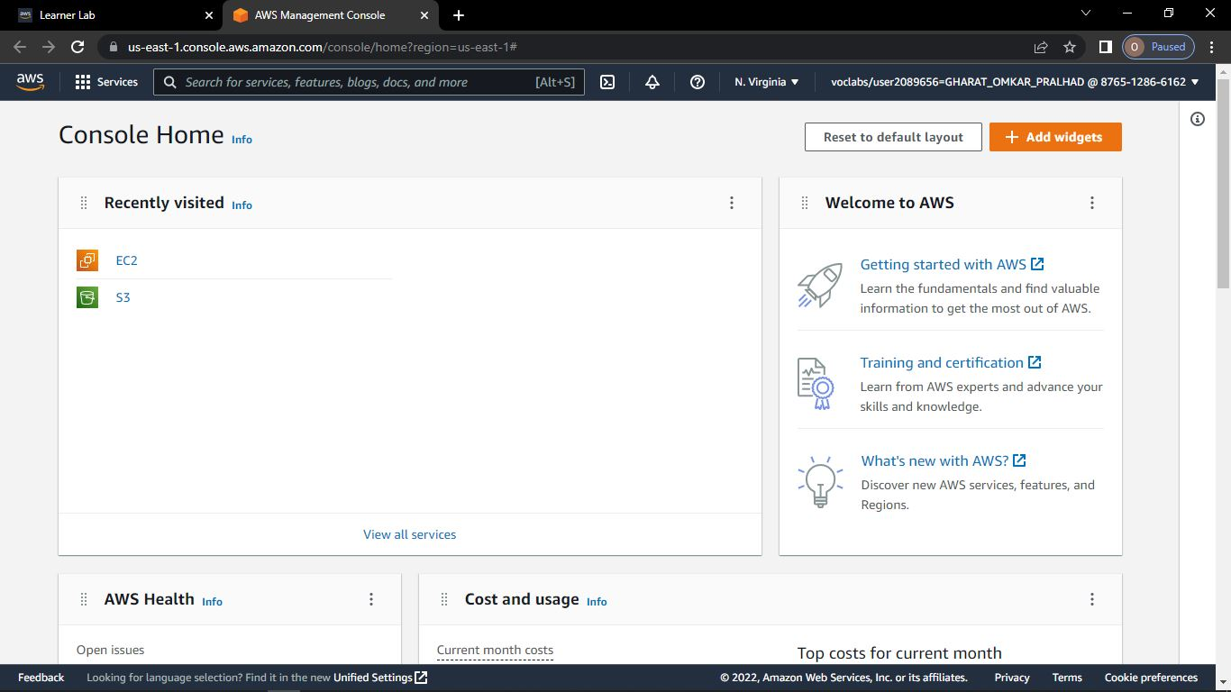

**Step-4: Click on create bucket**

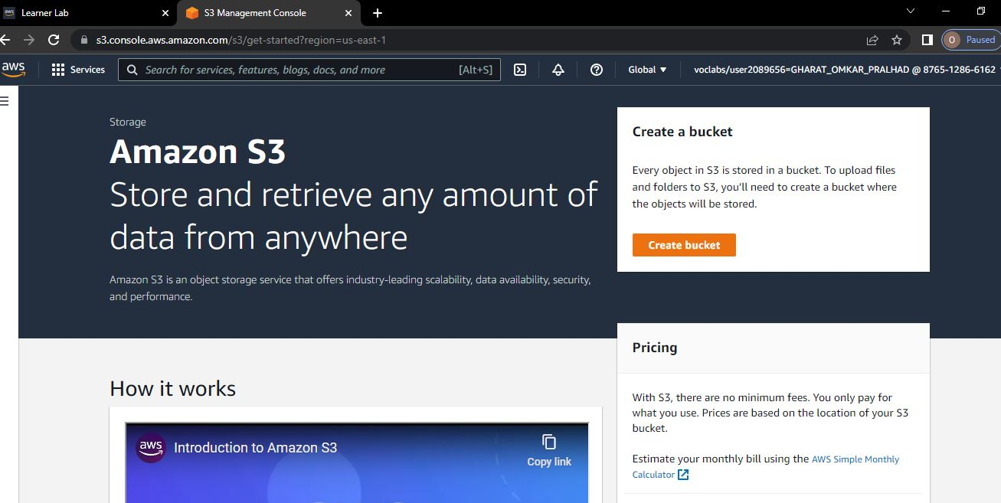

**Step-5: Give any name to Bucket**

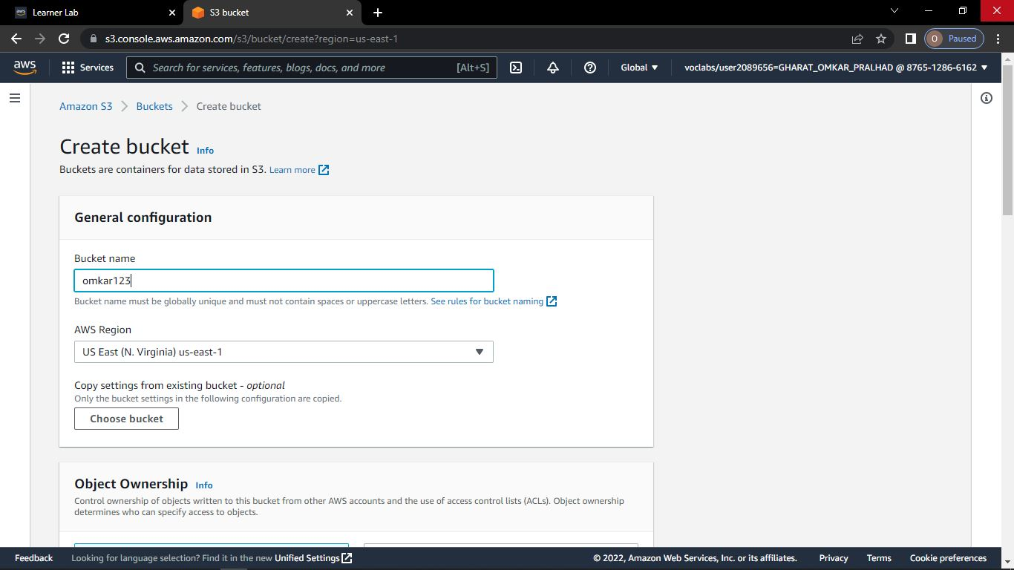

**Step-6: Select ACLs enabled and Click on Create Bucket.**

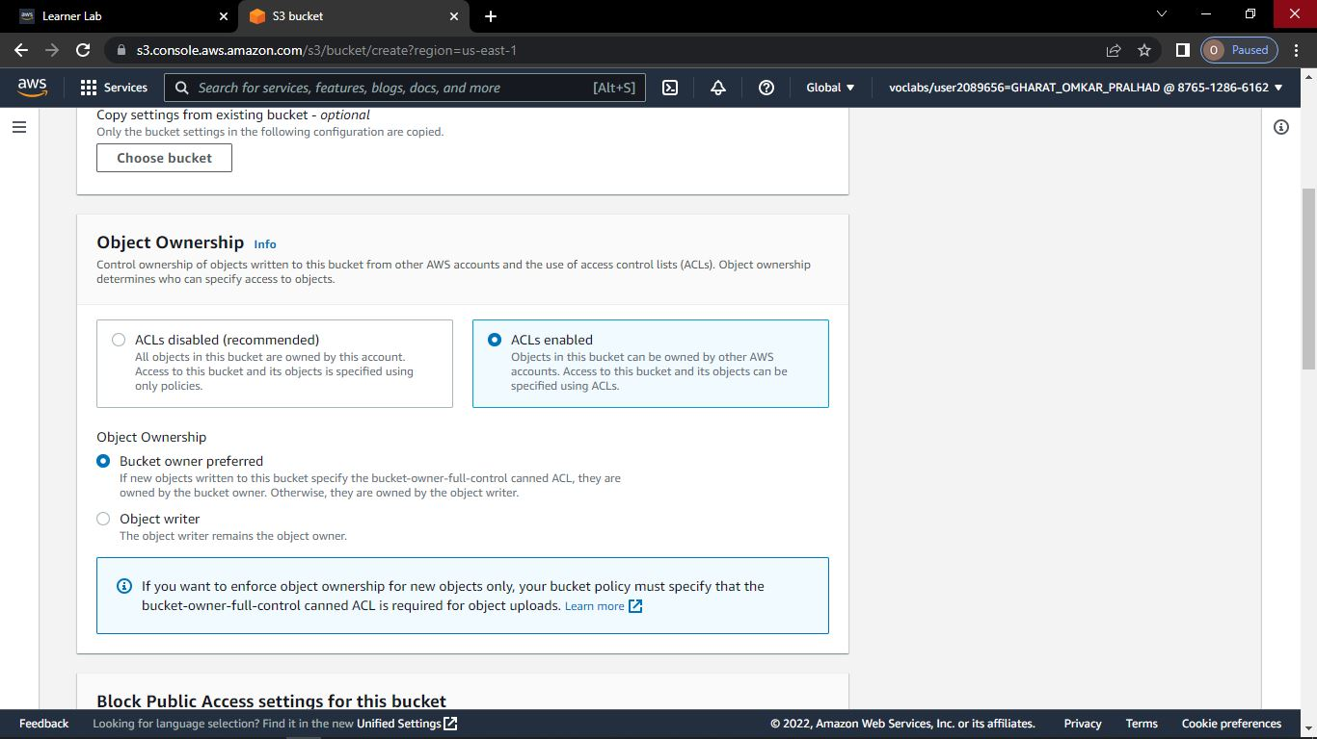

**Step-7: Click on Bucket Name**

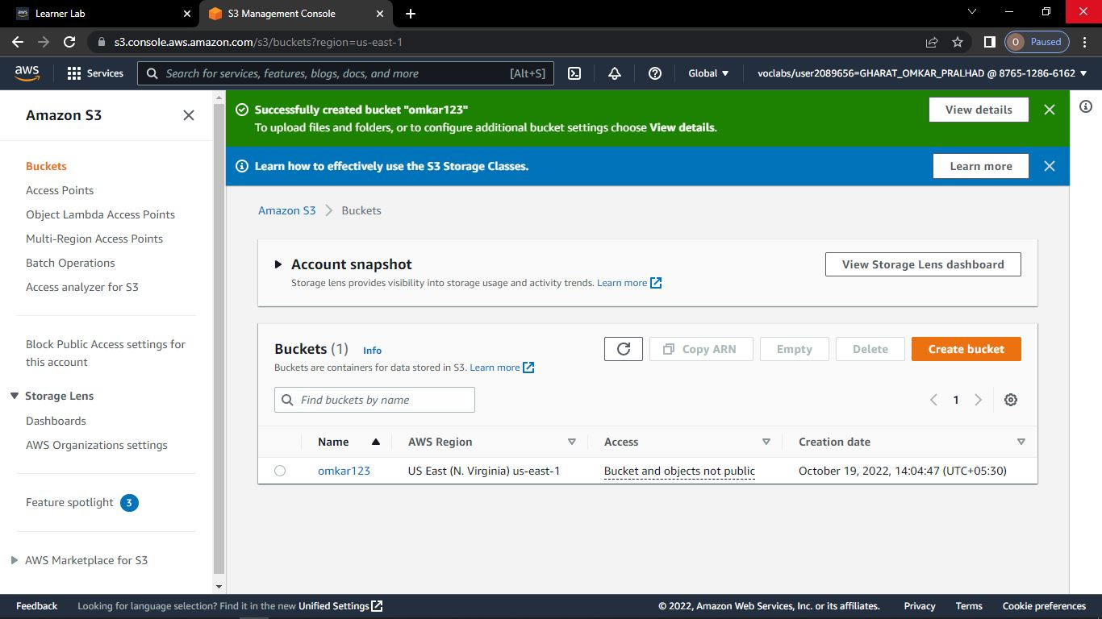

**Step-8: Click on Upload and upload any image file**

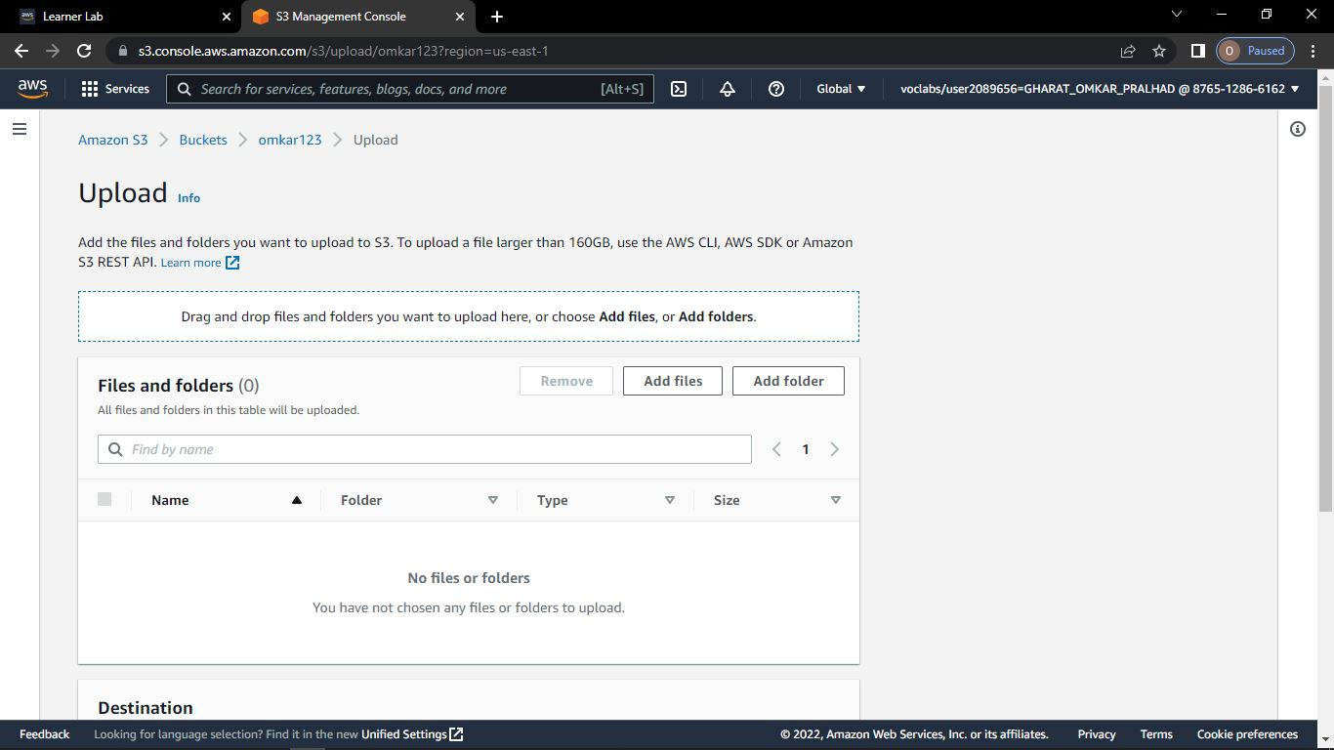

**Step-9: Select file and click on upload**

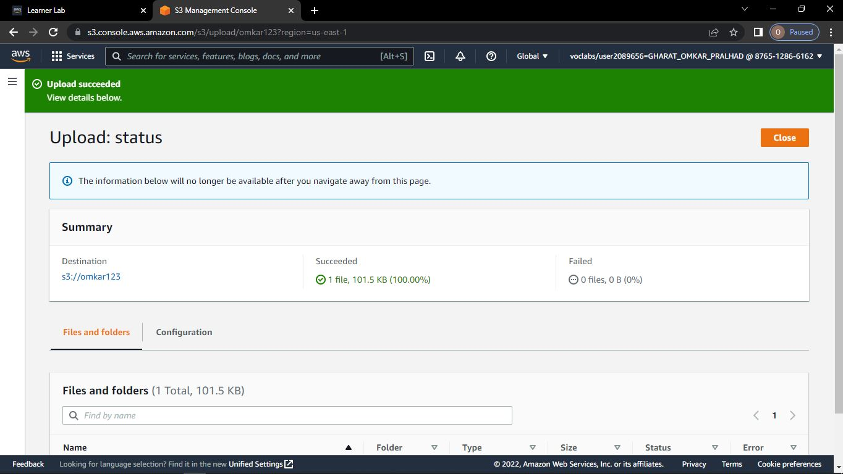

**Step-11: To display image**

**Click on bucket name -> Go to permissions -> click on Edit**

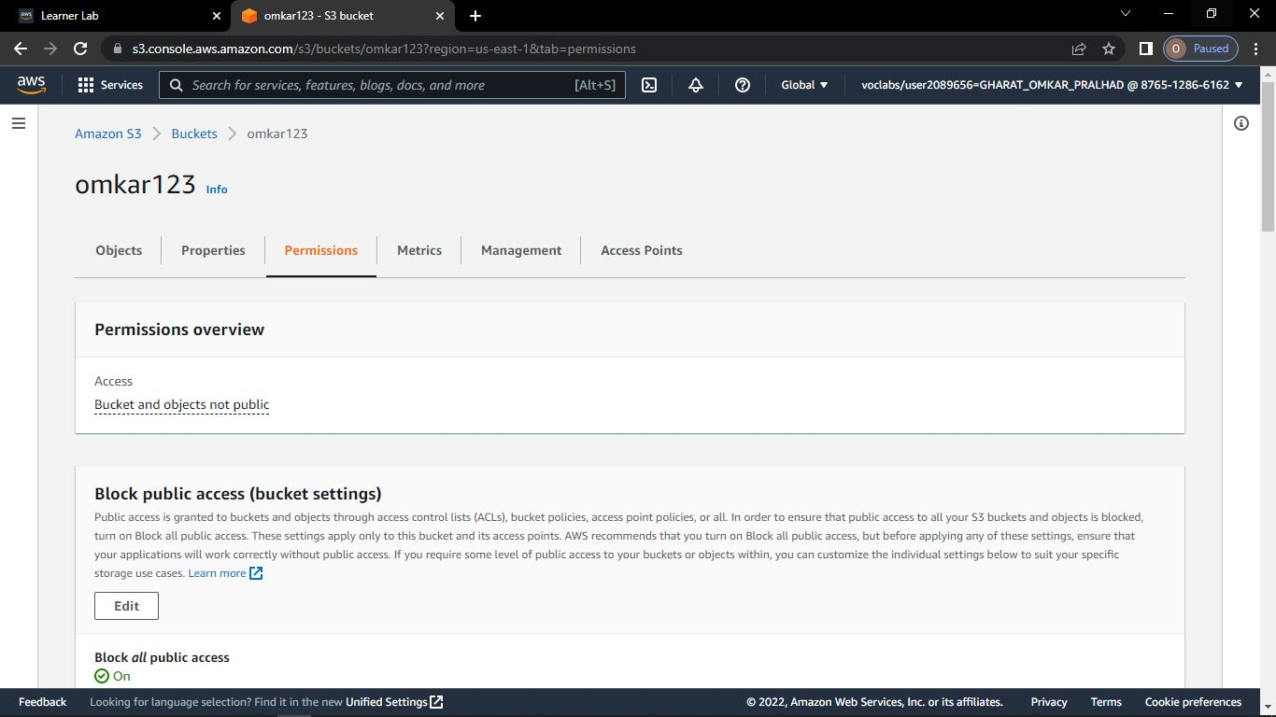

**Step-12: untick block public access**

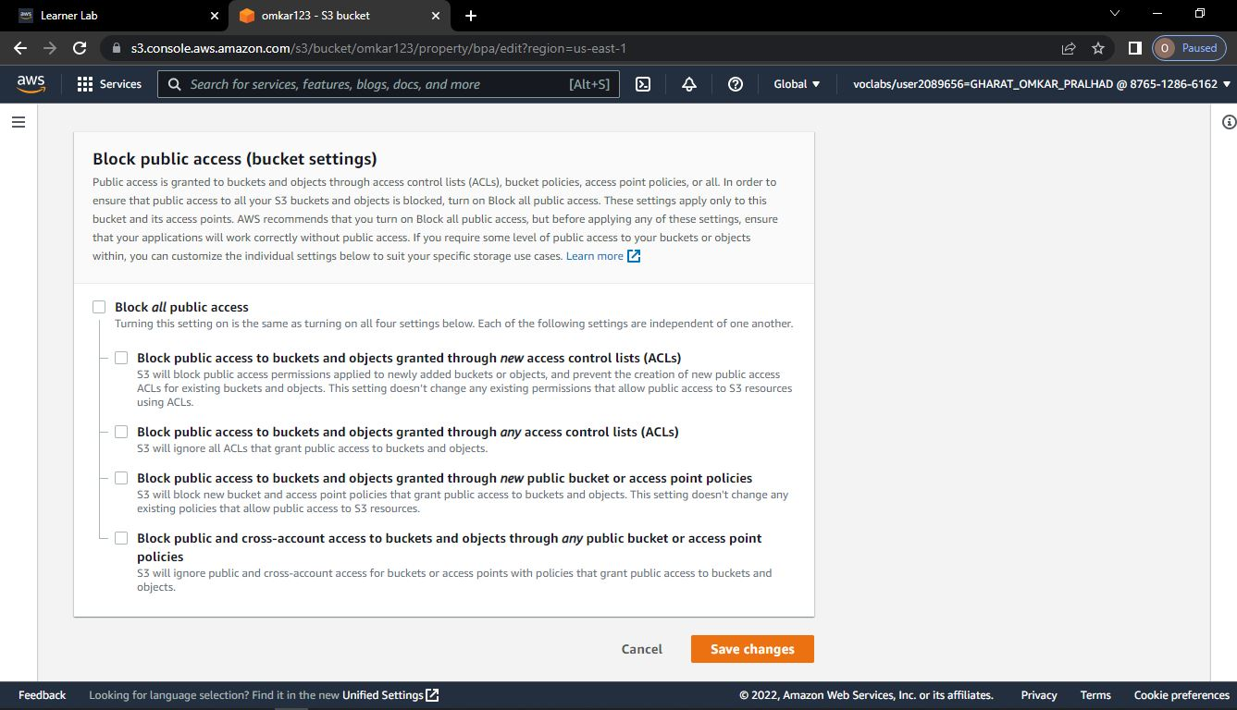

**Step-13: Click on Confirm**

**Step-14: Go to bucket name -> Click on Object Name**

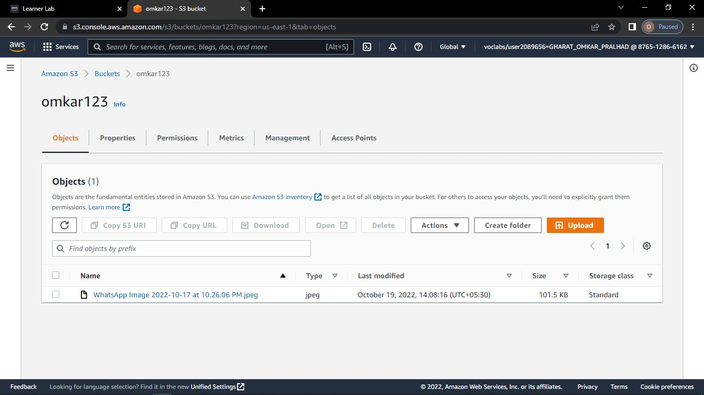

**Step-15: Go to permissions -> Click on Edit**

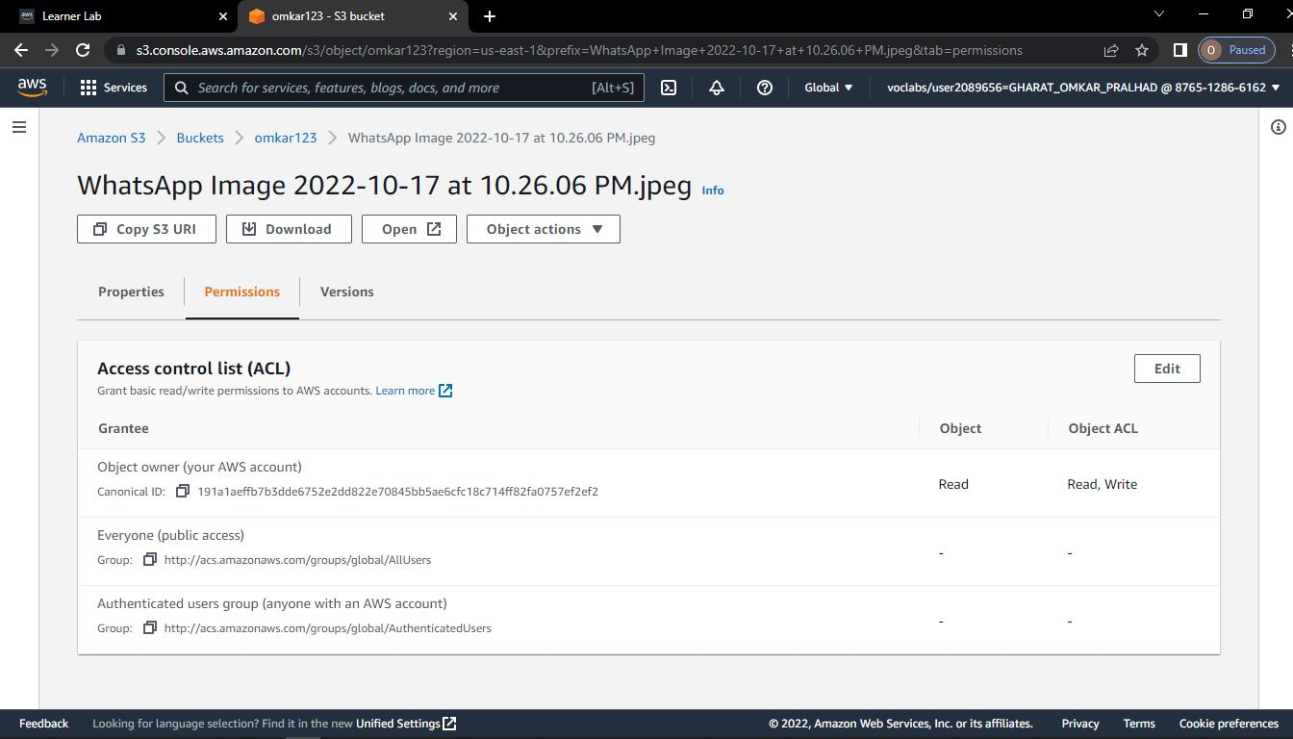



**Step-16: Tick on read**

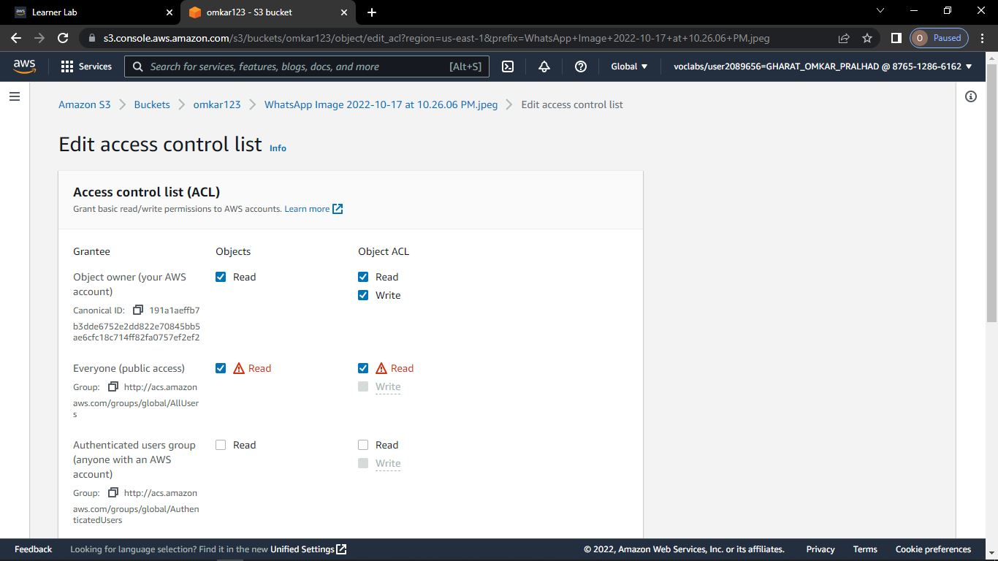

**Step-17: Click on save changes**

**Step-18: Click Object name**

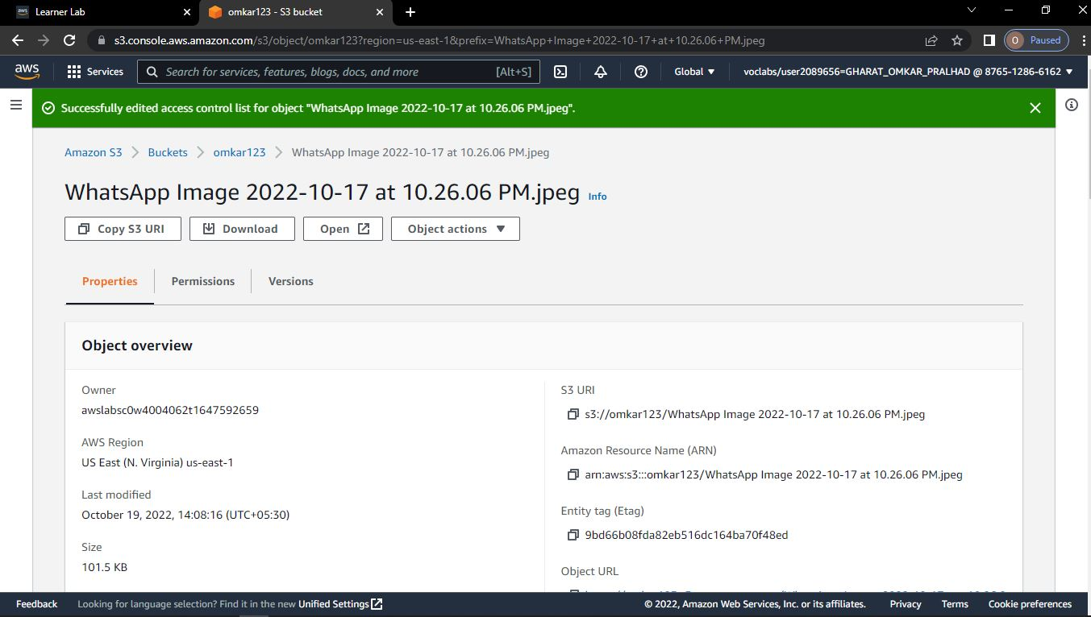

**Step-19: Click on Object URL**

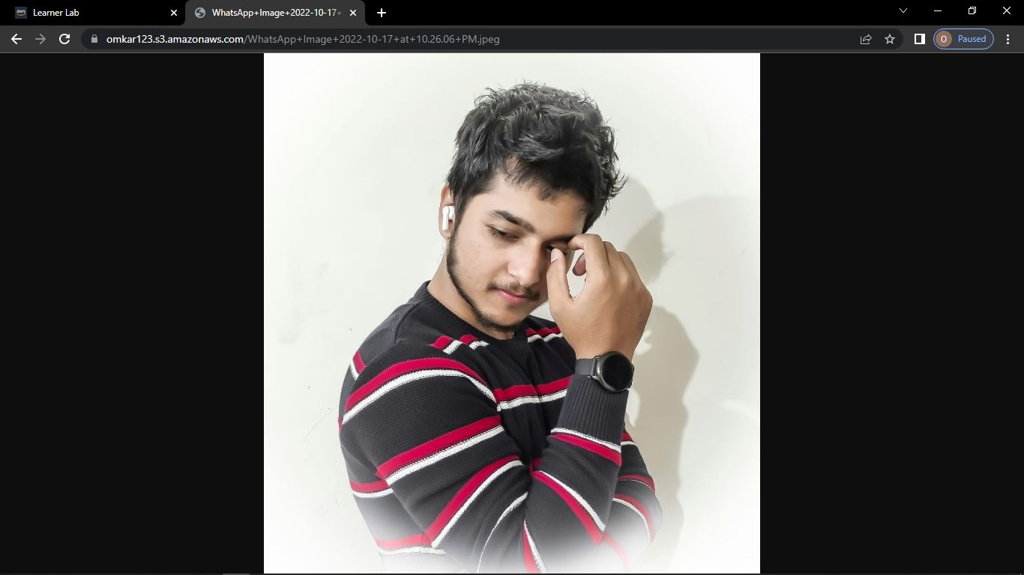

**Step-20: To Delete the object**

**Click on bucket name -> select object -> click on delete**

**Step-21: To confirm deletions -> type permanently delete -> click on delete object**

**Step-22: You have got the notification -> successfully deleted object -> click on bucket**

**Step-23: select bucket name -> click on delete**

**Step-24: To confirm deletion -> type bucket name -> click on delete bucket**

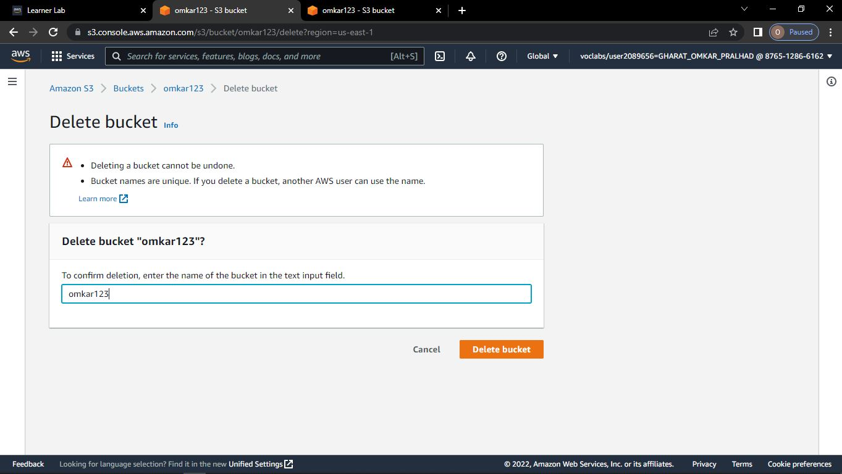

**Step-25: You have get the notification -> successfully deleted bucket**



